Recorder

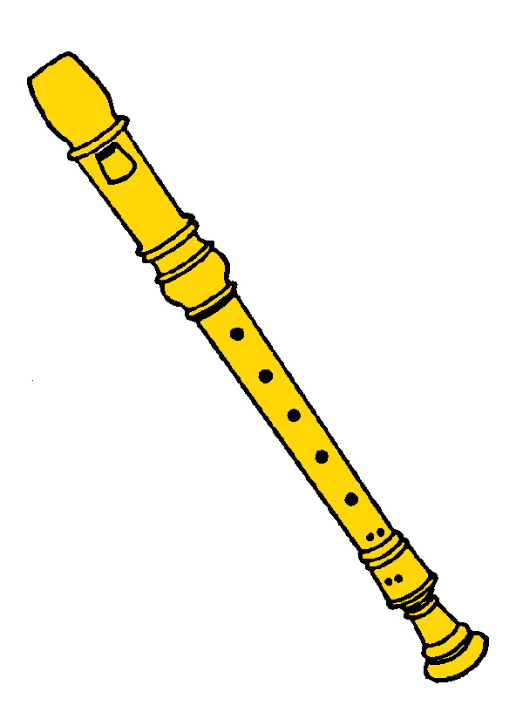

Print this page, laminate, cut into pieces that a recorder is made of. Children put these parzts on the grey recorder.

